[Array 14 (2022) 100153](https://doi.org/10.1016/j.array.2022.100153)

|  |  |  |
| --- | --- | --- |
|  |  |  |
|  | Contents lists available at ScienceDirect |  |
| Array |
| journal homepage: [www.sciencedirect.com/journal/array](https://www.sciencedirect.com/journal/array) |

A real-time collaborative machine learning based weather forecasting system with multiple predictor locations   
Tulsi Pawan Fowdur*, Rosun Mohammad Nassir-Ud-Diin Ibn Nazir   
*Department of Electrical and Electronic Engineering, University of Mauritius, Reduit, Mauritius*

|  |  |
| --- | --- |
| A R T I C L E I N F O | A B S T R A C T |
| *Keywords:*  Weather forecasting  Machine learning  Collaborative  Real-time  Cloud  Mobile | Weather forecasting is an important application in meteorology and has been one of the most scientifically and technologically challenging problems around the world. As the drastic effects of climate change continue to unfold, localised short term weather prediction with high accuracy has become more important than ever. In this paper, a collaborative machine learning-based real-time weather forecasting system has been proposed whereby data from several locations are used to predict the weather for a specific location. In this work, five machine learning algorithms have been used and tests have been performed in four different locations in Mauritius to predict weather parameters such as Temperature, Wind Speed, Wind Direction, Pressure, Humidity, and Cloudiness. The weather data were collected using the OpenWeather API from a mobile as well as a desktop edge device. The data were stored as a JSON file in both the IBM Cloudant database and a local MySQL database. Analytics were performed on both a local server that captures the incoming data from the edge device and via a servlet deployed on the IBM cloud platform. Five machine learning algorithms namely Multiple Linear Regres-sion (MLP), Multiple Polynomial Regression (MPR), K-Nearest Neighbours (KNN), Multilayer Perceptron (MLP) and Convolutional Neural Network (CNN) were tested using both collaborative and non-collaborative methods. The experiments showed that the collaborative regression schemes achieved 5% lower Mean Absolute Percentage Error (MAPE) than non-collaborative ones and the Multiple Polynomial Regression (MLR) algorithm out-performed all the other algorithms with errors ranging from 0.009% to 9% for the different weather parameters. In general, the results showed that collaborative based weather forecasting with multiple predictor locations can potentially increase the accuracy of the predictions in machine learning algorithms. |

**Credit author statement**

The authors confirm that the work presented is their own work and all information taken from other sources have been duly referenced.

**1. Introduction**

Weather forecasting aims to determine the state of the atmosphere over a given forecast period at a specific location. The weather can be described as variations in atmospheric variables such as temperature, wind speed and direction, humidity, sun-shine, cloudiness and precipi-tation [1]. With the advent of the Internet of Things (IoT), it is possible to obtain real-time weather predictions. Multiple weather sensors can be deployed at a low cost to collect weather data in different locations. Machine learning algorithms can then be applied to the collected data to perform predictions with a high level of accuracy [2]. In addition to IoT,

the Infrastructure as a Service (IaaS) model of commercial cloud plat-forms is well suited for applications such as weather forecasting that require computational resources sporadically. Renting high-end servers to execute applications that require bursty computational demands has the potential to be more cost-effective than purchasing and maintaining dedicated hardware. This is because cloud users pay only for the time the resources have been used [3]. Recently, several research have focused on the application of IoT, machine learning and cloud computing to develop real-time weather forecasting systems. An over-view of some of these schemes is given next.

In [4], David Irwin et al. proposed CloudCast, a mobile application that provides personalized short-term weather forecasting. The aims of this work were to investigate the hypothesis that current cloud platform connectivity and diversity could mitigate the impact of data staging and computational latency for Nowcasting. The architecture consisted of linking the radar sensor network of the Collaborative Adaptive Sensing

* Corresponding author.

*E-mail addresses:* [p.fowdur@uom.ac.mu](mailto:p.fowdur@uom.ac.mu) (T.P. Fowdur), [mohammad.rosun2@umail.uom.ac.mu](mailto:mohammad.rosun2@umail.uom.ac.mu) (R.M. Nassir-Ud-Diin Ibn Nazir).

<https://doi.org/10.1016/j.array.2022.100153>   
[Received 27 October 2021; Received in revis](https://doi.org/10.1016/j.array.2022.100153)ed form 19 February 2022; Accepted 1 April 2022   
Available online 14 April 2022   
2590-0056/© 2022 The Authors. Published by Elsevier Inc. This is an open access article under the CC BY license (<http://creativecommons.org/licenses/by/4.0/>).

*T.P. Fowdur and R.M. Nassir-Ud-Diin Ibn Nazir*  *Array 14 (2022) 100153*

of the Atmosphere (CASA) centre with the Meteorological Command and Control (MC & C) to regulate the radar scanning. DiCloud was used to control access to the Amazon’s Elastic Compute Cloud (EC2) re-sources to track the cost associated with the individual Nowcast re-quests. A nowcasting algorithm was used to predict high impact weather events for short time intervals. The authors observed high accuracy for 10 min Nowcasts. Further testing showed a 2 min delay for the delivery of a 15 min Now-casts image to a mobile client. The study revealed that commercial and research cloud services can be used for real-time now-casting applications.

In [5], Bobby D. Gerardo et al. presented a Flash Flood Warning System using SMS with advanced warning information. The system ar-chitecture consisted of a remote monitoring device made of an ultra-sonic sensor, pulse detector, a wireless modem, a FEZ Domino board and a 6-V battery charged by a solar panel. The water level and speed were measured and sent to a server. The server application and the modem which was used to issue SMS messages to subscribers were both simu-lated. To test the framework, water levels and velocity were recorded for seven days. The collected data was used to train an MLR model to predict future water flow. Using the predicted values, a risk value was calcu-lated which was then used to determine a threshold to issue warnings to users.

An experimental analysis of a cloud-based real-time weather fore-casting system was made by S. G. Totad et al. to investigate how the Cloud and IoT can be used for weather data collection and prediction [6]. The experiment architecture consisted of two DHT11 sensors to measure temperature and humidity and an Arduino board connected to a Raspberry pi. Data from the sensor were sent to the Arduino board, the Raspberry pi fetched the data and stored them in a public cloud through ThingSpeak. To perform analysis and prediction based on the collected data, one year of prior data was fetched from the cloud and correlation analysis of the parameters was then performed. An ARIMA model was generated for predicting the values for the upcoming year. The results showed satisfactory prediction results for the first two successive years. Beyond that, the prediction accuracy started to drop.

T.P. Fowdur et al. [7] made use of an IoT based weather monitoring system to develop a cloud-based real-time weather forecasting system. The aim was to investigate the accuracy of different data mining tech-niques and developed three adaptive schemes to select the appropriate algorithms when performing prediction for a given Nowcast. The ar-chitecture consisted of a weather monitoring node, a Raspberry pi 3 and a database server. The monitoring system was made up of weather sensors that measure weather conditions, a weather shield that was connected to the sensors and an Arduino board. An XBee shield with a WiFi module was stacked onto the Arduino board allowing the moni-toring module to be connected to the Raspberry pi 3 wirelessly. Recor-ded data were sent from the monitoring module to the Raspberry pi for processing and storage. Several data mining algorithms including MLR, KNN, ARIMA were used for forecasting the different weather variables. To test the system, data for the previous 11 days were used, a stepwise regression using the aforementioned algorithms was performed using a window of 2 h to predict for the next intervals of 20, 40 and 60 min. The results showed a general increase in error as the prediction interval in-creases. The error using the adaptive algorithms were lower compared to non-adaptive ones. The lowest error achieved was 0.454% for lumi-nosity and the highest error was 45.56% for precipitation.

In [8], the authors proposed using a six-layer Convolutional Neural Network (CNN) for forecasting severe convective weather (SCW) con-ditions. The study aim was to compare the CNN model to other machine learning algorithms including Support Vector Machine (SVM), Linear Regression (LR) and Random Forest Classifiers. To train the models, five years of severe weather observations were used from the National Centers for Environmental Prediction (NCEP) final analysis data. A large sample of data for each severe weather type was selected for training. The CNN model used consisted of six layers using a softmax classifier. After training the model, a sample of 50 unlabeled NCEP data was fed to

2

*T.P. Fowdur and R.M. Nassir-Ud-Diin Ibn Nazir*  *Array 14 (2022) 100153*

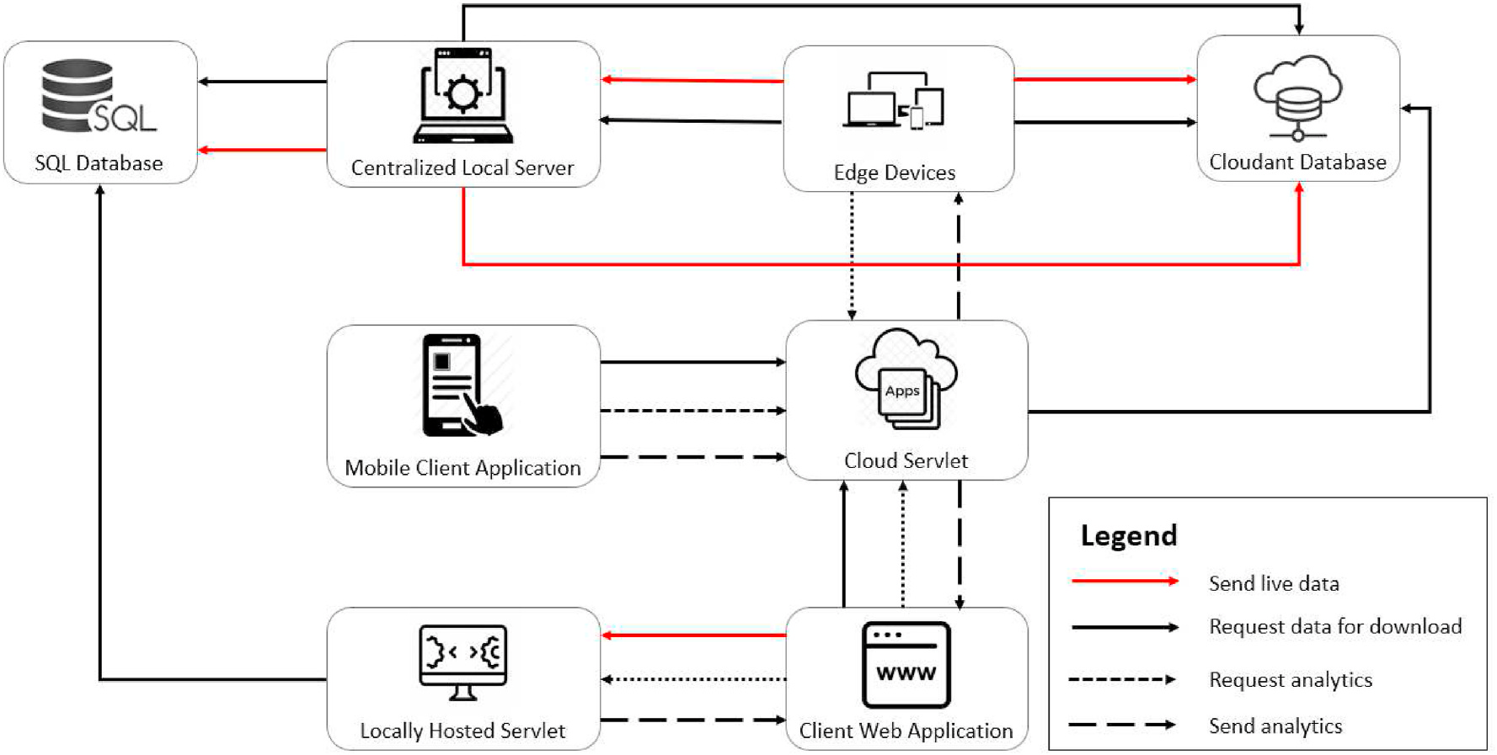

**Fig. 1.** System data flow.

several predictor regions to predict the data for a target region to achieve better prediction accuracy.

(ii) To the best of our knowledge a complete system with local and cloud servers, interactive mobile, desktop and web applications to access weather data forecasts seamlessly with collaborative weather forecasting, has not been proposed in any other work. (iii) Compared to Ref. [9], this work provides a performance analysis on six different weather parameters for collaborative forecasting with detailed treatment on the algorithms and architecture developed.

This work therefore provides an important architectural and math-ematical framework for state of the real-time weather forecasting sys-tems. Moreover, it investigates the aspect of collaborative weather forecasting which has a lot of potential to significantly improve forecasts in correlated regions. The proposed architectures and multi-platform applications also provide ease of deployment and scalability.

The rest of the paper is organized as follows. Section 2 describes the system model and the proposed collaborative machine learning algo-rithms. Section 3 gives the results obtained with a detailed analysis. Section 4 concludes the paper.

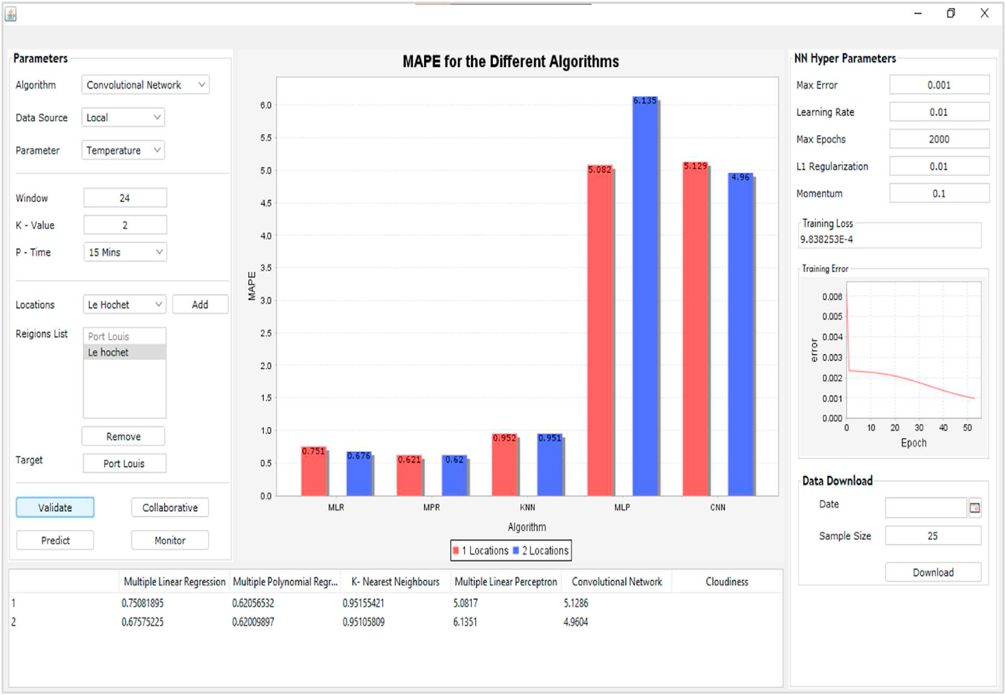

**Fig. 2.** Centralized local java server app.

3

*T.P. Fowdur and R.M. Nassir-Ud-Diin Ibn Nazir*  *Array 14 (2022) 100153*

**2. System model and algorithms for collaborative weather forecasting**

In this section, the complete system model for weather forecasting consisting of the local server, mobile and desktop edge devices, cloud- hosted servlet and web application is first described. After that, the modifications that have to be made to the conventional machine learning algorithms, in order to perform collaborative forecasting are described.

*2.1. System architecture for weather data collection and analytics*

Fig. 1 shows a diagram detailing the data flow in the entire system. The system extends the one described in Ref. [17] by adding a mobile client with an interactive interface specifically designed for weather forecasting in Mauritius. Moreover, the centralized local server in Ref. [17] is replaced by a local server that can perform collaborative weather forecasting using weather parameters for different regions to predict the weather for a given region. Same applies to the cloud servlet and locally hosted servlet.

The system consists of edge devices (mobile and desktop) that will send a request to the OpenWeather API [18] to request real-time weather parameters for a given region. These parameters are sent to the Local Server or directly to the cloud. The centralized local server can either store the values on a local MySQL database or send them to an IBM cloudant database. Analytics can be performed on the local server, the cloud-hosted servlet or the locally hosted servlet. A Web application has also been developed to allow users to monitor weather parameters and request predictions. Moreover, a dedicated android client for weather forecasting in Mauritius has been developed which shows an interactive map of the country with weather forecasts obtained from the cloud-hosted servlet. More details on each component of this system are given in the following subsections.

*2.1.1. Centralised local server for collaborative weather forecasting*  To implement the centralised local server, an application written in Java was created. Fig. 2 shows a screen capture of the centralized local server layout. The desktop application has the following functionalities:

• Monitors incoming socket connections from edge devices (android & desktop), captures the incoming data and stores the weather data in the local SQL database and cloud NoSQL database.

• Displays a real-time graph showing the variation of the different weather variables.

• Downloads data from either the local or cloud database for a specific date.

a specific sample size. • Downloads the latest data from either the local or cloud database for • Performs prediction for a specific location using the five machine learning algorithms.

• Performs a time-series cross-validation for the different algorithms. • Displays the MAPE of the cross-validation in a table and graph for easy comparison.

To predict the weather for a given time interval, the user clicks on the “Predict” button to perform prediction using the five possible machine learning algorithms. To download data, the user chooses a date and a sample size and then clicks on the “Download” button. The required data will then be fetched from the appropriate source and saved to the local storare in CSV format.

To perform collaborative regression, the user must enter the response location and choose at least two predictor locations. The training pa-rameters are then set using the provided textboxes. Then, the “Collab-orative” button is clicked which invokes the algorithms for collaborative regression described in Section 2.2. The MAPE of the prediction for each weather variable is then shown in the output table located at the bottom

4

*T.P. Fowdur and R.M. Nassir-Ud-Diin Ibn Nazir*  *Array 14 (2022) 100153*

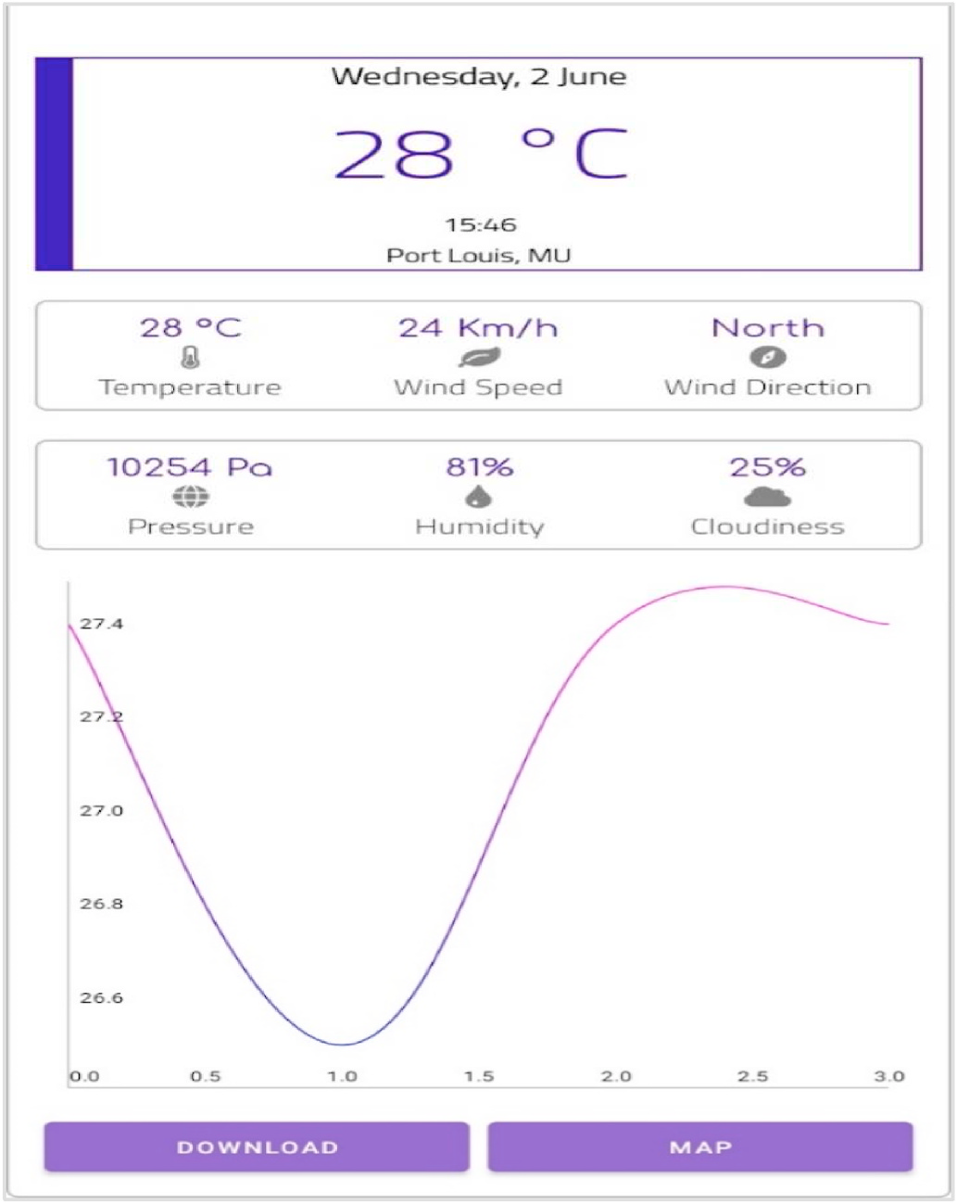

**Fig. 5.** Mobile client Main activity screen.

• Requests the Java servlet application for weather data for a specific date or fixed sample size.

The OpenWeather API [18] was used to collect data about current weather conditions every 15 min and store it in a database. To obtain the current weather condition for a specific location, the URL for the API call has to be properly formulated by specifying the city name, response type, units of measurement & API key as shown in Fig. 3.

To connect to the API, the JSOUP class was used. A connection to the URL was opened by using the connect() method of the static JSOUP class and then the get() method fetched and parsed the HTML data into a Document object. The Document object was converted to a String using the text() method. The response String was then type-casted to a JSO-NObject. The necessary reading was extracted from the response and encapsulated in a JSONObject. The JSONObject was then sent either to the Local Server app or Cloudant platform for storage.

A detailed description of all source codes for the mobile and desktop edge devices is given in Ref. [17]. Fig. 4 shows the data collection process that has been implemented.

Every 15 min a new link following the format in Fig. 3 is generated based on the chosen location. The OpenWeather API is contacted using the JSOUP library which contacts the link generated and downloads the JSON response from the server. The necessary data from the JSON String is extracted and encapsulated in another JSON object. A check is per-formed whether the “Cloud” checkbox is ticked. If this is the case, the data is sent directly to the Cloudant database, else it is sent to the local server for storage in the SQL database.

*2.1.3. Mobile client application*   
 A mobile application was developed using the Android Studio IDE.

The application has the following functionalities:

• Displays the latest weather condition recorded.

5

*T.P. Fowdur and R.M. Nassir-Ud-Diin Ibn Nazir*  *Array 14 (2022) 100153*

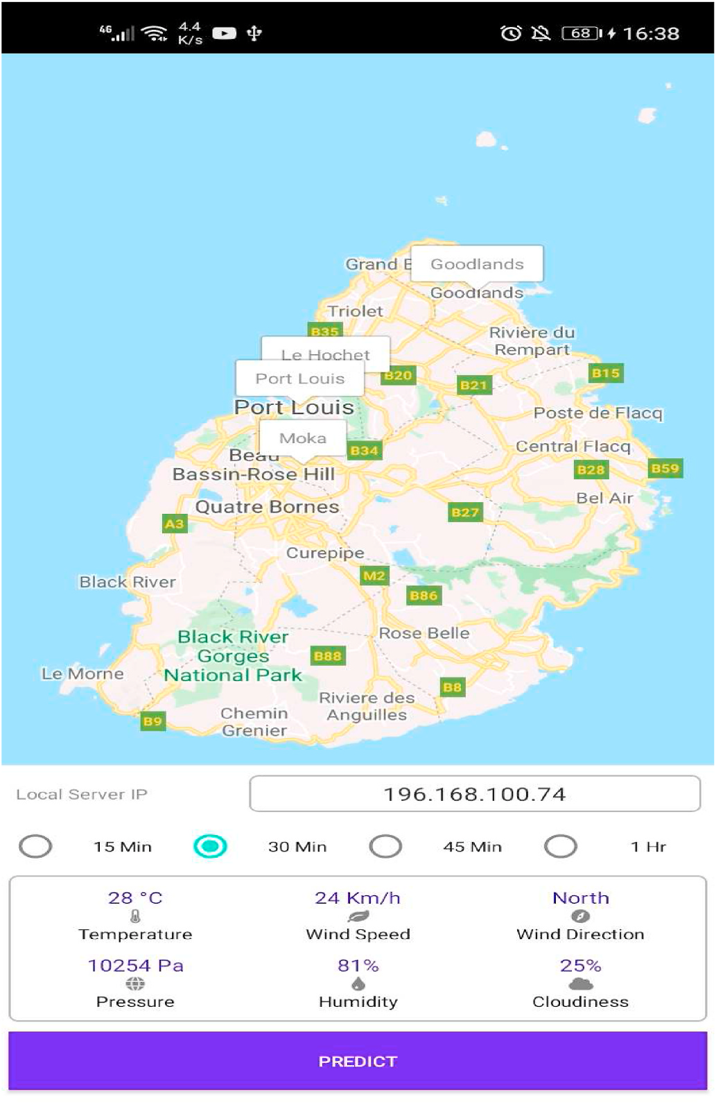

**Fig. 7.** MapActivity screen.

predicted values for the Temperature, Wind Speed, Wind Direction, Pressure, Humidity and Cloudiness after 30 min in this case.

*2.1.4. Web application*   
 The web application is a webpage that is displayed to users when they visit the servlet link. The webpage provides a graph that displays the variation of the weather parameters in real-time. The user can also download weather data for a specific date or only the last N readings. The page is also responsible for contacting either the cloud-hosted or the locally hosted servlet for analytics results and displaying it to the user.

A dynamic web application was written in the Eclipse IDE and deployed on the Bluemix server on IBM Cloud. The web app presents the users with a webpage where they can perform the following actions:

• Perform prediction on the cloud and get the results on their device. • Download weather data for a specific date or only the last N weather observations.

• Observe the variation of the weather parameters in a graph updated every 15 min. The update interval is chosen as 15 min because the values from the OpenWeather API are refreshed in the same time interval.

*2.1.5. Cloud hosted servlet*   
 The main function of the cloud-hosted servlet is to serve requests coming from end-users that visit the webpage. The servlet is responsible for the following functions:

6

*T.P. Fowdur and R.M. Nassir-Ud-Diin Ibn Nazir*  *Array 14 (2022) 100153*

**Table 1**   
Weather variables notations.

**Table 2**   
Regression response and predictor relationship.

|  |  |  |  |  |
| --- | --- | --- | --- | --- |
| **Parameter** | **Symbol** | Response Variable | Predictor Variables |  |
| Temperature  Wind Speed  Wind Direction  Pressure  Humidity  Cloudiness | *Tt*  *WSt*  *WDt*  *Pt*  *Ht*  *Ct* | Temperature  Wind Speed  Wind Direction  Pressure  Humidity  Cloudiness | Temperature  Wind Speed  Wind Direction  Pressure  Humidity  Cloudiness | Humidity  Temperature Temperature Temperature Temperature Humidity |

be seen in the modified mathematical models of the different machine

learning techniques used for collaborative prediction in the following

subsections.

*2.2.1. Collaborative multiple linear regression (MLR)*

In this paper, with multiple linear regression, equations involving a

general variable V1 to be predicted at time t + 1 with respect to the previously recorded value of V1 at time t and other related parameters

Vx(1), Vx(2), …, Vx(n) were formulated as per the following generic combination:

V1t+1 = *β*0(w) + *β*(1)(w) ​ Vx(1) + *β*(2)(w) ​ Vx(2) + … + *β*(n)(w) ​ Vx(n)

(1)

where.

window of size w. *β*0(w), *β*1(w), …, *β*n(w), are coefficients determined for a training

A combination of six multiple linear regression equations was

derived experimentally for the six weather parameters. To define the

equations, the notations in Table 1 are used to denote each weather

parameter.

The MLR conventional equations i.e. without collaborative data from

different locations, can be expressed as follows:

*Tt*+1 = *β*0(w) + *β*(1)(*w*) *Tt* + *β*(2)(*w*) *Ht* + *ε*  (2)

*WSt*+1 = *β*0(w) + *β*(1)(*w*) *WSt* + *β*(2)(*w*) *Tt* + *ε*  (3)

*WDt*+1 = *β*0(w) + *β*(1)(*w*) *WDt* + *β*(2)(*w*) *Tt* + *ε*  (4)

*Pt*+1 = *β*0(w) + *β*(1)(*w*) *Pt* + *β*(2)(*w*) *Tt* + *ε*  (5)

*Ht*+1 = *β*0(w) + *β*(1)(*w*) *Ht* + *β*(2)(*w*) *Tt* + *ε*  (6)

*Ct*+1 = *β*0(w) + *β*(1)(*w*) *Ct* + *β*(2)(*w*) *Ht* + *ε*  (7)

The MLR collaborative equations are expressed as summations as

follows:

*n*

*Tt*+1 = *β*0(w) +∑*β*((*i*\*2)−1 )(*w*) *Tt*(*i*) + *β*(*i*\*2)(*w*) *Ht*(*i* ) (8)

*n*

*WSt*+1 = *β*0(w) +∑*β*((*i*\*2)−1 )(*w*) *WSt*(*i*) + *β*(*i*\*2)(*w*) *Tt*(*i* ) (9)

*n*

*WDt*+1 = *β*0(w) +∑*β*((*i*\*2)−1 )(*w*) *WDt*(*i*) + *β*(*i*\*2)(*w*) *Tt*(*i* ) (10)

*n*

*Pt*+1 = *β*0(w) +∑*β*((*i*\*2)−1 )(*w*) *Pt*(*i*) + *β*(*i*\*2)(*w*) *Tt*(*i* ) (11)

*n*

*Ht*+1 = *β*0(w) +∑*β*((*i*\*2)−1 )(*w*) *Ht*(*i*) + *β*(*i*\*2)(*w*) *Tt*(*i* ) (12)

*n*

*Ct*+1 = *β*0(w) +∑*β*((*i*\*2)−1 )(*w*) *Ct*(*i*) + *β*(*i*\*2)(*w*) *Ht*(*i* ) (13)

7

*T.P. Fowdur and R.M. Nassir-Ud-Diin Ibn Nazir*  *Array 14 (2022) 100153*

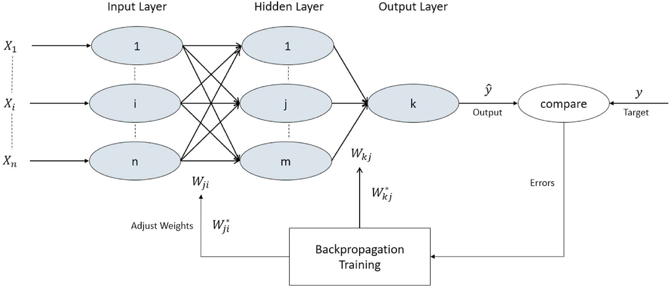

**Fig. 9.** Mlp network [23].

|  |  |  |  |
| --- | --- | --- | --- |
| Ht+1 = *β*0 + *β*1H1(t) + *β*2T1(t) + *β*11H1 | 2(t) + *β*12H1(t) ​ T1(t) + *β*22T1 | 2(t) | (20) |
| Ct+1 = *β*0 + *β*1C1(t) + *β*2H1(t) + *β*11C1 | 2(t) + *β*12C1(t) ​ H1(t) + *β*22H1 | 2(t) | (21) |

The conventional MPR equations for a second order model with

collaborative data, i.e. from different locations, can be expressed as the

summation in equation (14), where the independent variables X1 and X2

are replaced by the predictor locations as decribed in Table. Again the

collaborative MPR model given in equation (14) will lead to an increase

in complexity as compared to MPR that uses a single predictor location.

*2.2.3. KNN collaborative regression*

The K-Nearest Neighbours (KNN) algorithm is one of the simplest

machine learning algorithms. It is based on a lazy learning method

where the first K samples nearest to each sample test data are selected

[20]. In this paper, to measure the distance between the test instance

and the dataset the Euclidean distance function was used. For regres-

sion, the outcome was taken as the mean of the K nearest observations.

The formula to calculate Euclidean distance is:

*d*(*x, y*) =√̅̅̅̅̅̅̅̅̅̅̅̅̅̅̅̅̅̅̅̅̅̅̅̅̅̅∑ (22)

For each dimension, we subtract one point’s value from the other’s to

get the length of that side of the triangle in that dimension, square it, and

add it to our running total. The square root of that running total is our

Euclidean distance.

The Euclidean distance between the test data and the data in the

training window denoted, *dX*(*test data, window*), for each parameter can be summurised as follows:

*dT*(*test data, window*) =∑√̅̅̅̅̅̅̅̅̅̅̅̅̅̅̅̅̅̅̅̅̅̅̅̅̅̅̅̅̅̅̅̅̅̅̅̅̅̅̅̅̅̅̅̅̅̅̅̅̅̅̅̅̅̅̅̅̅̅̅̅̅̅̅)( ) )2 + *i* )( ) )2 (23)

*n*

*dWS*(*test data, window*) =∑√̅̅̅̅̅̅̅̅̅̅̅̅̅̅̅̅̅̅̅̅̅̅̅̅̅̅̅̅̅̅̅̅̅̅̅̅̅̅̅̅̅̅̅̅̅̅̅̅̅̅̅̅̅̅̅̅̅̅̅̅̅̅̅)( ) )2 + *i* )( ) )2 (24)

*n*

*dWD*(*test data, window*) =∑√̅̅̅̅̅̅̅̅̅̅̅̅̅̅̅̅̅̅̅̅̅̅̅̅̅̅̅̅̅̅̅̅̅̅̅̅̅̅̅̅̅̅̅̅̅̅̅̅̅̅̅̅̅̅̅̅̅̅̅̅̅̅̅)( ) )2 + *i* )( ) )2 (25)

*n*

*dP*(*test data, window*) =∑√̅̅̅̅̅̅̅̅̅̅̅̅̅̅̅̅̅̅̅̅̅̅̅̅̅̅̅̅̅̅̅̅̅̅̅̅̅̅̅̅̅̅̅̅̅̅̅̅̅̅̅̅̅̅̅̅̅̅̅̅̅̅̅)( ) )2 + *i* )( ) )2 (26)

*n*

8

*T.P. Fowdur and R.M. Nassir-Ud-Diin Ibn Nazir*  *Array 14 (2022) 100153*

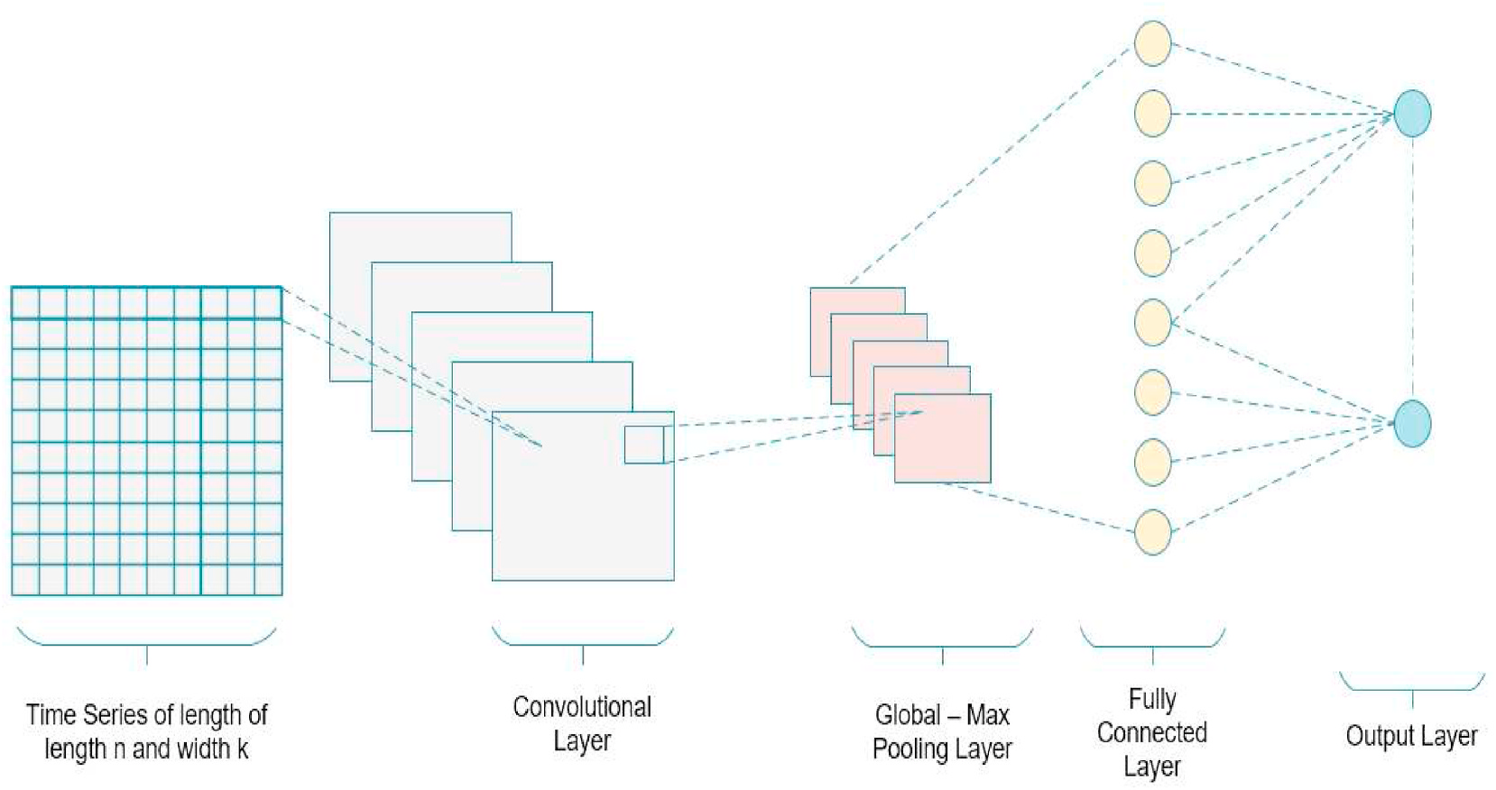

**Fig. 10.** CNN network architectures.

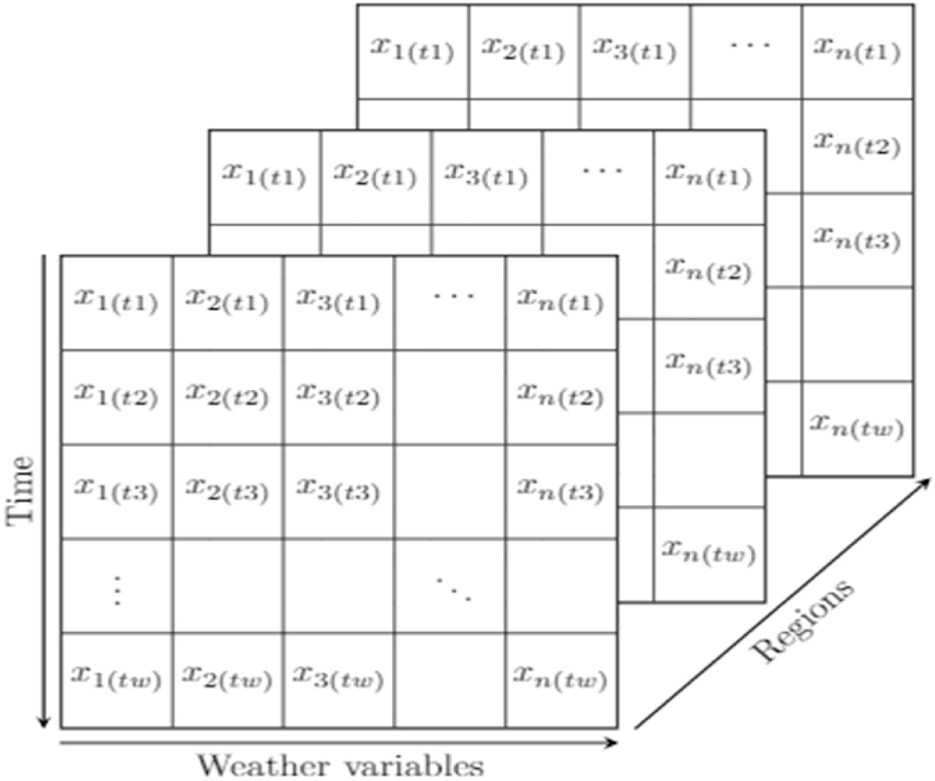

**Fig. 11.** CNN input tensor.

shows the architecture of an MLP network and how it is trained.

Before feeding data to a neural network, the data must first be normalized to enhance the computations and achieve more accurate results [24]. In this paper, the min-max normalization given in equation

(30) has been used.

*Xnormalised* =*Xcurrent* ~~−~~ *Xmin ~~X~~max* − *~~X~~min*  (30)

where, Xcurrent is the current value, Xmin is the minimum value of X and Xmax is the maximum value of X.

The MLP input which consists of inputs for different time steps can be summarised as follows:

*MLPinput* = [ *X*1*t*1*, X*2*t*1…*X*(*n*)*t*1*, X*1*t*2*, X*2*t*2*,* …*, X*(*n*)*t*2*,* …*. X*(*n*)*tn* ]   
where, X1, X2, …, X(n) are the predictor variables for timestep t(n). In the non-collaborative case, the complexity is less as there is only one input layer as compared to collaborative MLP regression which has n input layers for n predictor locations.

*2.2.5. CNN collaborative regression*   
 A Convolutional Neural Network (CNN) is an advanced neural network designed to work with two-dimensional data, although one- dimensional and three-dimensional data can also be fed to the network. This type of network automatically extracts features from the input data grid and has been used mainly for object detection. The CNN architecture consists of an input layer, several hidden layers (convolu-tional, pooling and fully connected layers), and an output layer as shown in Fig. 10 [25].

The input to the CNN network is shown in Fig. 11.

The input tensor consists of a 3D matrix where each row represents

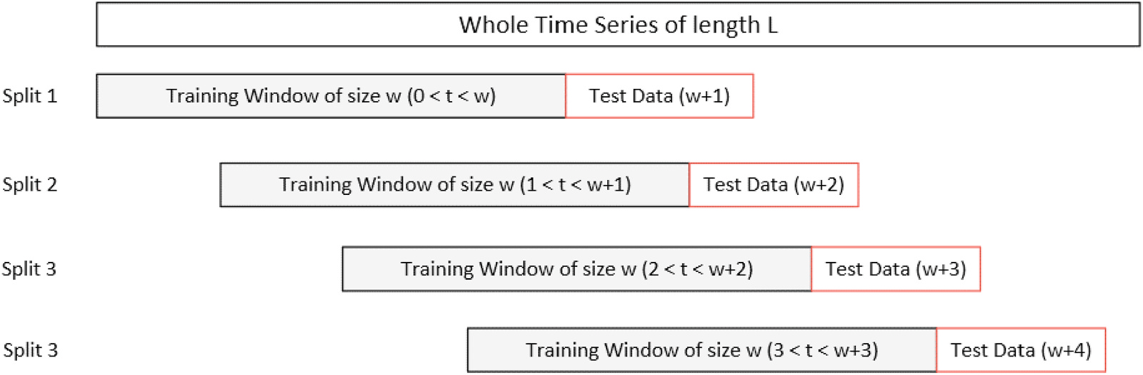

**Fig. 12.** Sliding window validation.

9

*T.P. Fowdur and R.M. Nassir-Ud-Diin Ibn Nazir*  *Array 14 (2022) 100153*

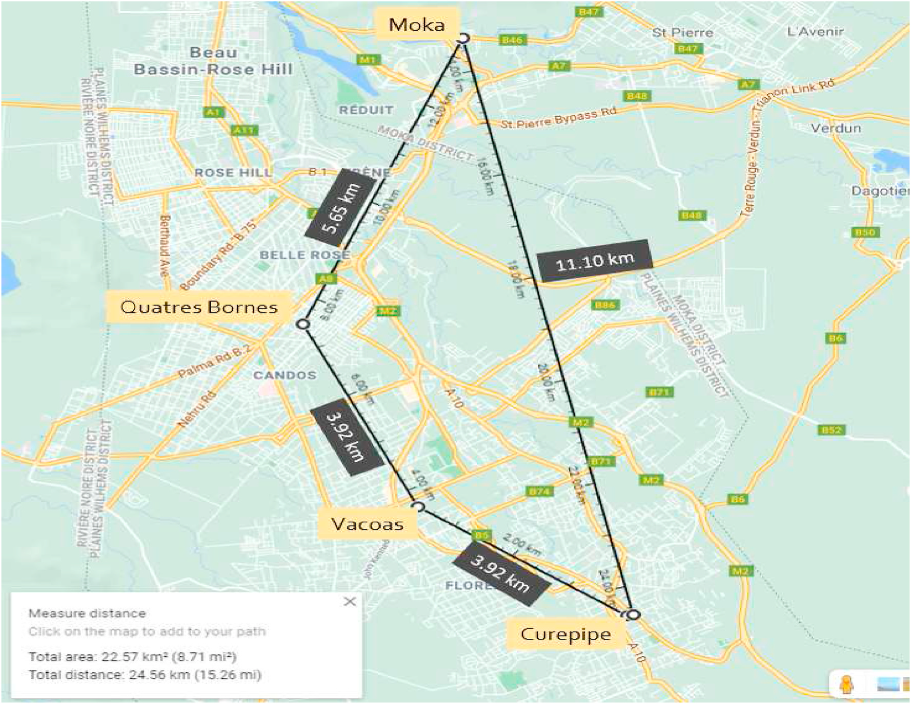

**Fig. 13.** Locations on google maps.

the predictor variables at a specific time step for a region. For non- collaborative regression, the number of predictor reigions is one. For collaborative regression, data from different regions are combined to form the model input tensor which results into a more complex 3D tensor input matrix as compared to the conventional non –collaborative case.

**3. System testing and performance analysys**

In this section, the performance of each machine learning model for each weather variable has been tested and the effect of using collabo-rative regression to predict the weather condition for a specific location is analyzed.

**Table 3**   
Dataset details for simulation.

Location Details

|  |  |  |
| --- | --- | --- |
| Location Name  Curepipe  Vacoas  Quatres Bornes  Moka  Dataset Details  Observation Period  1st May to 31st May 2021 | Altitude (m)  561  430  313  203 | Area [km2]  24  110.45  25.45  231 |
| Samples per Location 2976 | Weather Parameters  1. Temperature (◦C)  2. Wind Speed (ms−1) 3. Wind Direction – (◦) 4. Pressure – (Pa)  5. Humidity – (%)  6. Cloudiness – (%) |

10

*T.P. Fowdur and R.M. Nassir-Ud-Diin Ibn Nazir*  *Array 14 (2022) 100153*

**Table 4**   
Algorithms parameters details for simulation.

**Table 6**   
MLP network parameters optimization.

|  |  |  |  |
| --- | --- | --- | --- |
| Machine Learning Algorithm Parameters | Hyper Parameters | Training MLP[1k] | Training MLP [10k] |

|  |
| --- |
| Algorithms Name Parameter Set  MLR Window size = 36  Ridge parameter = 0.0001  MPR Window size = 36  Model order = 2nd order  Ridge parameter = 0.0001  KNN Window size = 36  K = 3  Distance function = Euclidean distance  **Deep Learning Algorithm Parameters**  Parameter Name MLP CNN  Input Size [1,72] [32,2, n_locations]  Activation Function Sigmoid Tanh  Max Epochs 1000 1000  Max Error 0.0001 0.0001  Momentum 0.9 0.9  Learning Rate 0.01 0.01  L2 Regularization 0.0001 0.0001 |

**Table 5**   
Experiment details.

|  |  |  |  |
| --- | --- | --- | --- |
| Experiment | Predictor Locations | Response Location | Prediction Time |
| Experiment 1 Experiment 2 Experiment 3 | Curepipe  Moka  Curepipe  Quatres Bornes Vacoas  Moka  Quatres Bornes Vacoas | Curepipe  Moka  Curepipe | 15 Mins  15 Mins  15 Mins |
| Experiment 4 | Moka | 15 Mins |

The Mean Absolute Percentage Error (MAPE) between the actual and predicted values for each parameter was then computed over the whole dataset as given in equation (31).

|  |  |  |  |
| --- | --- | --- | --- |
| *MAPEparam* =1 | *N* ∑ | |*Actual*(*i*) − *Predicted*(*i*)| |*Actual*(*i*)| | (31) |

where, N represents the total number of points in the dataset.   
 The overall percentage error was then calculated for all the algo-rithms used as given in equation (32).

*N*   
*Average Errormodel* =1 *param*=1∑ *MAPEparam*  (32)

Table 3 below shows a summary of the regions and dataset being used.

*3.2. Simulation algorithms*

For the simulation, cross-validation was performed using the following five algorithms:

• Multiple Linear Regression (MLR)   
• Multiple Polynomial Regression (MPR) • K-Nearest Neighbours (KNN)   
• Multilayer Perceptron (MLP)   
• Convolutional Neural Network (CNN)

The parameters for each algorithm are given in Table 4.

*3.3. Simulation procedures*

Four experiments were performed to investigate the effect of collaborative regression on the accuracy of the sliding window

11

*T.P. Fowdur and R.M. Nassir-Ud-Diin Ibn Nazir*  *Array 14 (2022) 100153*

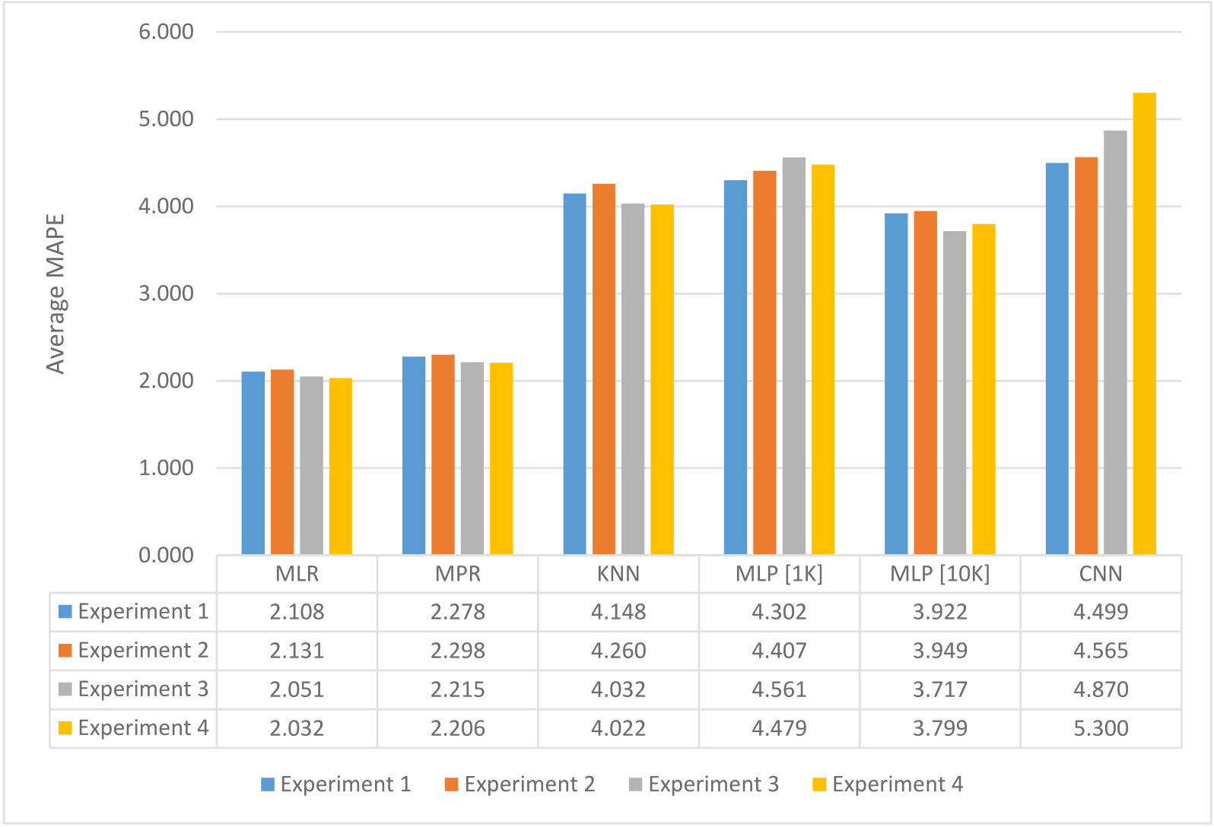

**Fig. 14.** Performance of the algorithms for the four experiments.

approach:

1. The complexity increases with the number of predictor locations, hence only the most significant predictor locations should be used based on experimental data.

2. The training window should be kept relatively small as real-time forecasts have to be supported. This can lead to a loss in prediction accuracy in certain cases, although this can be compensated for with collaborative forecasting and better tuning of the hyperparameters.

The deep learning networks can be optimized by tuning the hyper- parameters. For a demonstration, the parameters for the MLP network were modified and each experiment was repeated with the new hyper- parameters. Table 6 shows the hyperparameters that were modified.

*3.4. Experimental results*

The results for experiments 1–4 has been tabulated in Table 7.

A bar chart is plotted to compare the error performance of each al-gorithm with and without collaborative regression. Fig. 14 shows the average error of each algorithm for experiments 1 to 4.

As can be observed from the bar chart, the average MAPE obtained by the machine learning algorithms for the collaborative experiments (Experiments 3 & 4) was generally lower when compared to the non- collaborative ones (Experiments 1 & 2). This decrease in error can be attributed to the increasing number of correlated explanatory variables. The linear regression models such as MLR and MLP are able to better exploit the correlated variables, therefore, decreasing the overall error.

The deep learning networks, however, experienced a mean increase of 8% for the average MAPE. There was a 3.79% increase in average error for the MLP network and a 12.2% increase for the CNN network. However, the increase in error can be attributed to the small training dataset and unoptimized network. The deep learning networks can be optimized by tuning the hyper-parameters. The experiment labelled MLP [10K] demonstrates that with the necessary parameter tuning, the overall error for the deep learning networks can be further minimised.

It can be observed from the above graph, that the optimized network

12

*T.P. Fowdur and R.M. Nassir-Ud-Diin Ibn Nazir*  *Array 14 (2022) 100153*

deep learning networks can further decrease the overall error obtained.

**4. Conclusions**

In this paper a collaborative weather forecasting system to perform data analytics on weather data using machine learning algorithms and cloud computing facilities was developed. Essentially, two edge devices were used to collect data from the OpenWeather API. Analytics were performed both on a local server and a cloud hosted servlet using MLR, MPR, KNN, CNN and MLP. An interactive android app was developed to provide mobile clients with the latest weather conditions in some re-gions of Mauritius. The algorithms were tested using sliding window cross-validation for a prediction interval of 15 min. A series of four ex-periments were performed consisting of two collaborative regression and two non-collaborative regression. The experiments showed that the machine learning algorithms were 65% more accurate than the deep learning networks. However, after tuning some hyperparameters, the MLP network was operating on par with the classical learning algo-rithms. The collaborative schemes gave a 5% lower average MAPE when compared to non-collaborative schemes. The most performing algorithm was MLR with a MAPE ranging between 0.009 and 6% and the worst performing algorithm was CNN with MAPE ranging between 8 and 16%. An important implication of the results obtained is that using collabo-rative regression can increase the accuracy of the prediction for a location. The testing of the different algorithms also demarcates from previous works [19,26] whereby data for only a single location was used. Similar to Ref. [9], significantly better accuracy was obtained by collaborative forecasting. However, in contrast to Ref. [9] where only the performance analysis was presented for temperature data, in this work six weather parameters are considered and detailed mathematical models for the collaborative machine learning are given. Moreover, a complete weather forecasting system with both local and cloud servers as well as different client devices have been developed by extending the work in Ref. [17]. This system allows testing using any number of pre-dictor locations desired. The most interesting contribution of this work is that collaborative regression can be used to increase the accuracy of weather predictions when using machine learning. However, to achieve good accuracy with neural networks, the hyperparameters must be tuned to provide a network for optimal operation. An interesting future work would be to use a stacking ensemble learning machine learning model to perform predictions. It involves combining the predictions from multiple regression models on the same dataset [27].

**Declaration of competing interest**

On behalf of all authors, the corresponding author states that there is no conflict of interest.

**Acknowledgments**

The authors would like to thank the University of Mauritius for providing the necessary facilities to conduct this research.

**References**

[1] Wiston M, Km M. Weather forecasting: from the early weather wizards to modern- day weather predictions. J Climatol Weather Forecast 2018. [https://doi.org/](https://doi.org/10.4172/2332-2594.1000229) [10.4172/2332-2594.1000229](https://doi.org/10.4172/2332-2594.1000229). 06 02.

[2] [Han J, Kamber M, Pei J. Data](https://doi.org/10.4172/2332-2594.1000229) mining: concepts and techniques. In: Han J, Kamber M, Pei J, editors. Data mining: concepts and techniques. San Francisco, CA, itd: Morgan Kaufmann; 2012. [https://doi.org/10.1016/B978-0-12-381479-](https://doi.org/10.1016/B978-0-12-381479-1.00001-0. 2012) [1.00001-0. 2012](https://doi.org/10.1016/B978-0-12-381479-1.00001-0. 2012).

13